
RTS local development setup
Roof Top Solar Setup Instructions
20-06-2022
Installing SAP Commerce Cloud 2011 for use with Spartacus
The following instructions describe how to install and configure SAP Commerce Cloud release 2011 for use with a Spartacus storefront.

- Download and extract (using 7-zip) all necessary suites from the SharePoint.
  - SAP Commerce Cloud 2011
  - Telco & Utilities Accelerator
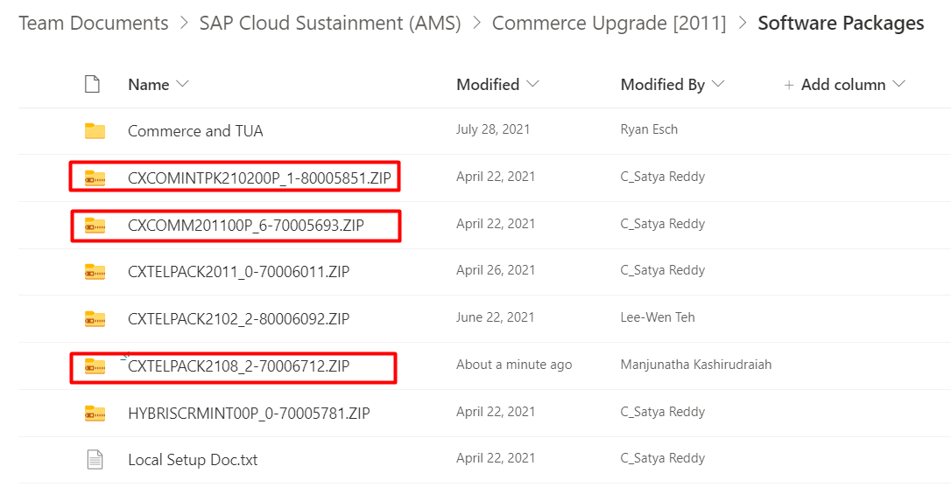
(Following instructions assume the Commerce Cloud 2011 is extracted to a folder called COMMCX2011)

- Copy modules related to Telco & Utilities Accelerator to hybris folder.
CXTELPACK2108\hybris\bin\modules\* à CXCOMM2011\hybris\bin\modules\
CXCOMINTPK2102\hybris\bin\modules\* à CXCOMM2011\hybris\bin\modules\

- Download and extract from SharePoint (b2ctelcocms) and copy the extension to modules/b2c-telco-accelerator directory.

- Clone the source code from the branch – feature/DTE01_rts_b2b_spartacus_foundation.
git clone -b “feature/DTE01_rts_b2b_spartacus_foundation” https://github.com/dteenergy/DTEC4.git

- Create symbolic link for “custom” and “crm-integration” folders under this path CXCOMM2011\hybris\bin.
mklink /J "D:\RTS\CXCOMM201100P6\hybris\bin\custom" "D:\RTS\CXCOMM201100P6\DTEC4\hybris\bin\custom"
mklink /J "D:\RTS\CXCOMM201100P6\hybris\bin\crm-integration" "D:\RTS\CXCOMM201100P6\DTEC4\hybris\bin\crm-integration"

- Download data folder from SharePoint and unzip under this path CXCOMM2011\hybris\data
- Delete “library.info” file from CXCOMM2011\hybris\data\backoffice\widgetlib\deployed\
- Copy config files from source code to COMM2011 (\CXCOMM2011\DTEC4\config à \CXCOMM2011\hybris\config)
- Go to the Platform directory and run “ant clean all”
cd D:\RTS\CXCOMM201100P6\hybris\bin\platform
ant clean all
- Renew the license for HSQL DB (https://www.helphybris.com/2018/07/how-to-install-temp-hybris-license.html)
  - Remove installedSaplicenses.properties from the license folder – \hybris\config\licence
  - Go to the Platform directory and run the ./license.sh-temp CPS_SQL or license.bat -temp CPS_SQL.
- start the hybris server
hybrisserver.bat
- Perform system update in HAC.
- Import necessary impex files.
- Check OCC API calls are configured and working fine.
https://localhost:9002/occ/v2/dtespa/cms/pages?lang=en&curr=USD

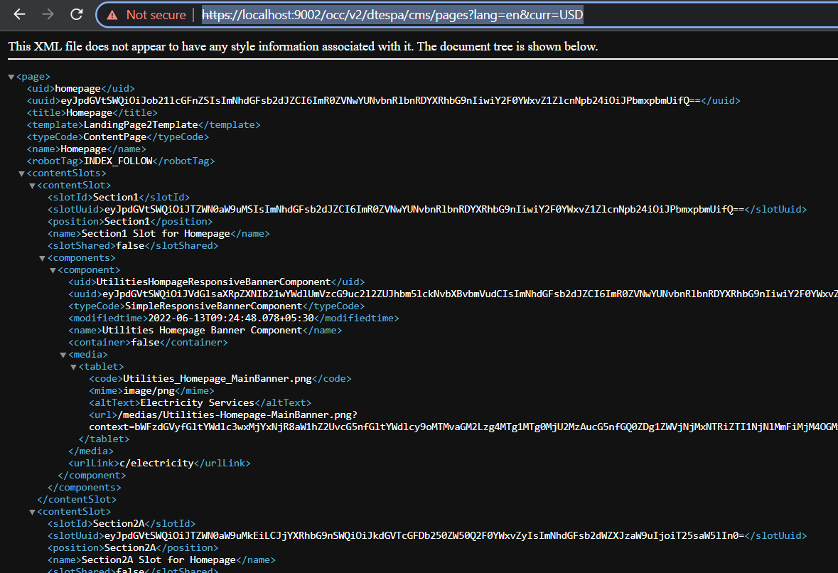

- Start Spartacus storefront.
cd D:\RTS\CXCOMM201100P6\DTEC4\js-storefront\dteutilspastore
yarn install
yarn start
